10 Ways to Use a Highlighter to Help Students
Scissor skills - highlight the cutting line to help give student an extra visual cue or thicker line. | 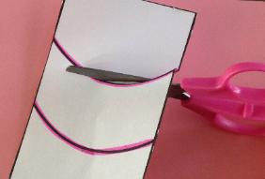 | Memory - have students highlight information to make sure that they remembered to include it. For example, if students forgets to write their name on papers, have student highlight name after writing it. | 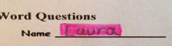
Coloring skills - highlight the borders so student only colors within the lines. | 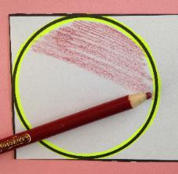 | Highlight lines for the student to practice tracing different paths. | 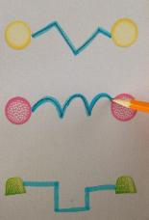
Following instructions - Highlight each step that a student needs to complete. | 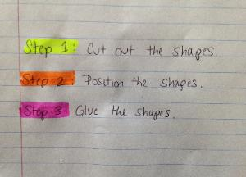 | Highlight boxes for the student to write the answer to encourage proper letter sizing and orientation. | 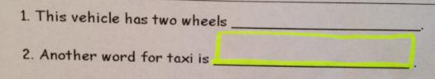
Highlight the bottom of lined paper to help with letter sizing. | 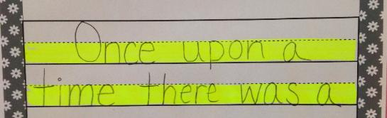 | Outline main ideas of the text to remind the student where to look for answers.
Page organization - highlight the left and right margins of the page to cue student to only write between the lines. |  | Photocopy text and have students follow along with highlighter while other students read out loud to help sustain attention. | 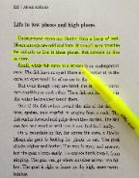
*Adapted from YourTherapySource.com

Questions? Ask your Occupational Therapist at CommuniCare Therapy.
Contact ________________________613.738.1884 ext. _______

